**SCREENSHOTS:  
OUTPUT & RUNNING TIME OF THE PROGRAM**

1. **AUTO GENERATE RETAILERS’ INFORMATION IN FILE**

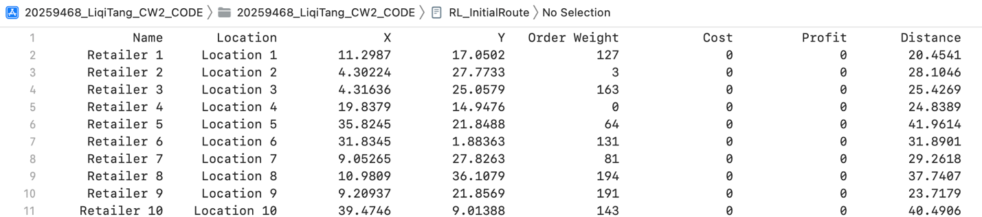

1. **AUTO GENERATE RETAILERS’ INFORMATION AND MAIN MENU**

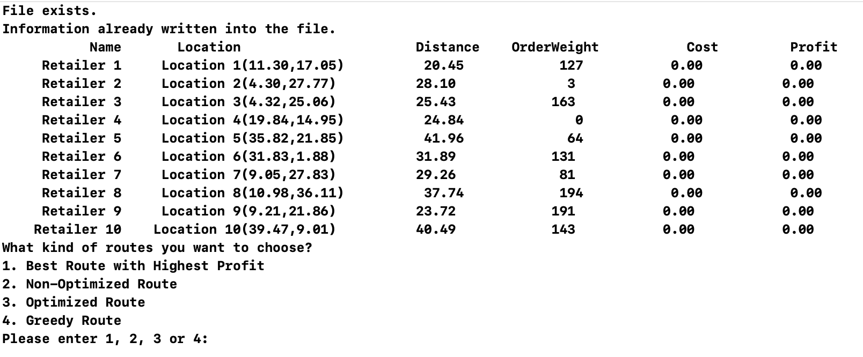

1. **OPTION 1 ---- BEST ROUTE WITH THE HIGHEST PROFIT**

1. **OPTION 2 ----- NON-OPTIMISED ROUTE**

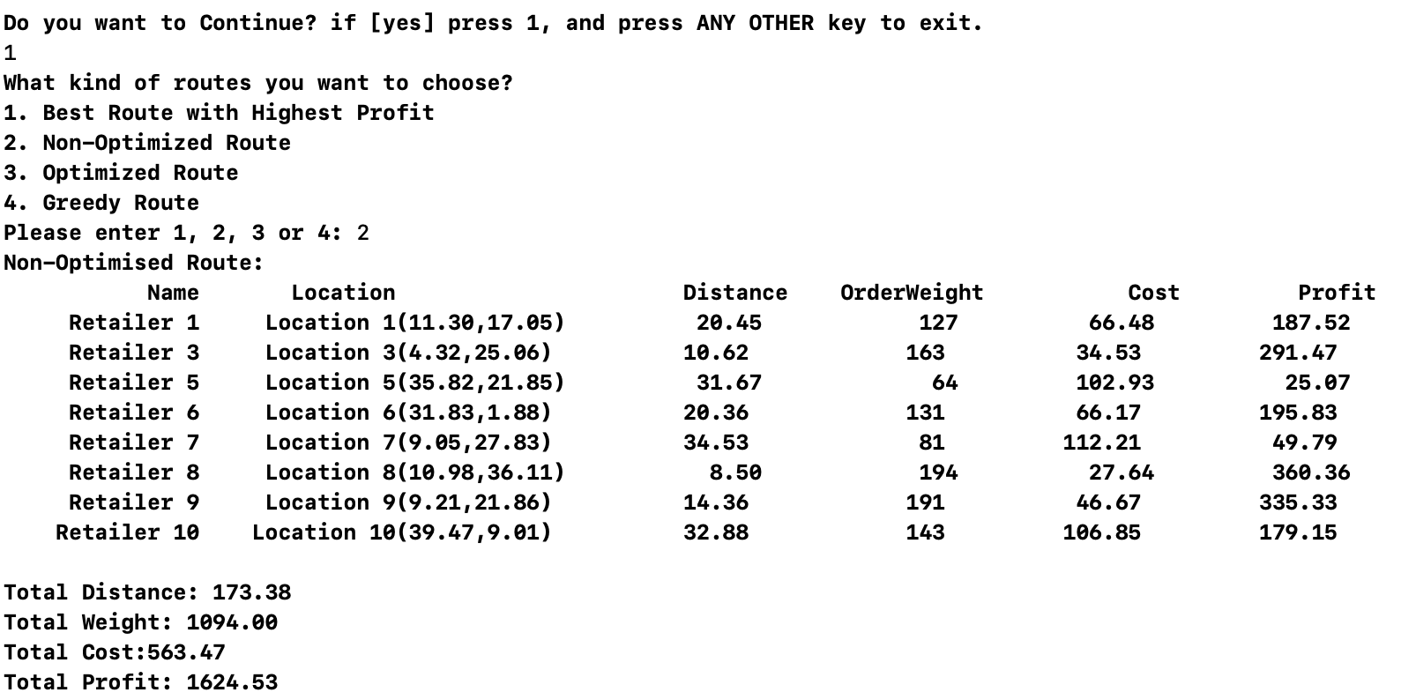

1. **OPTION 3 ----- OPTIMISED RPUTE**

1. **OPTION 4 ----- GREEDY ROUTE**

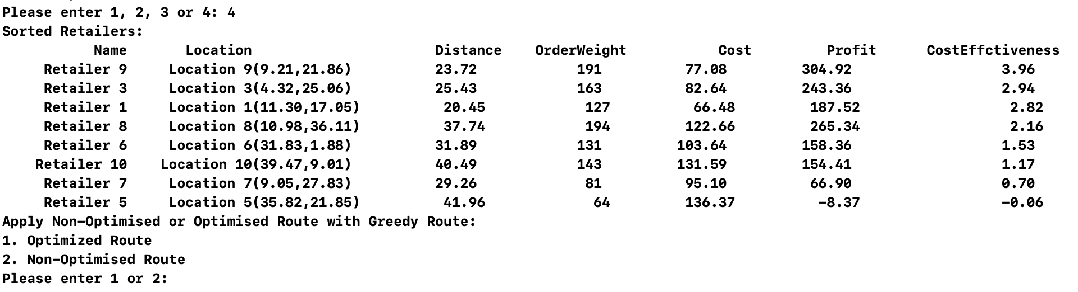

1. **OPTION 4.1 -----GREEDY WITH OPTIMISED ROUTE**

1. **OPTION 4.2 ----- GREEDY WITH NON-OPTIMISED ROUTE**

1. **USER INPUT VALIDATION**
2. **MAIN MENU USER INPUT VALIDATION TEST**

1. **GREEDY ROUTE USER INPUT VALIDATION TEST**

1. **PRINT OUT FILE USER INPUT VALIDATION TEST**

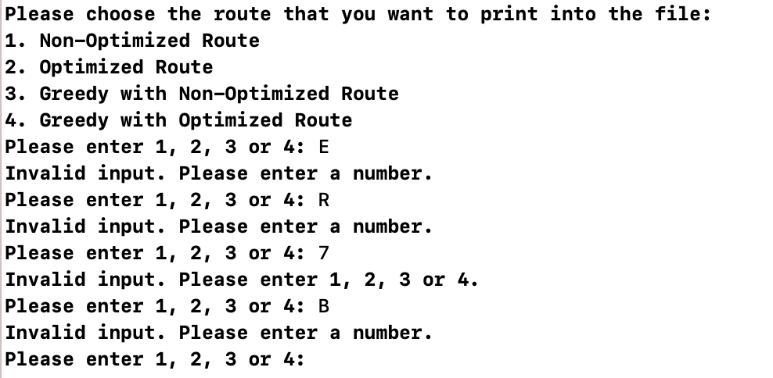

1. **TIME MANAGEMENT**

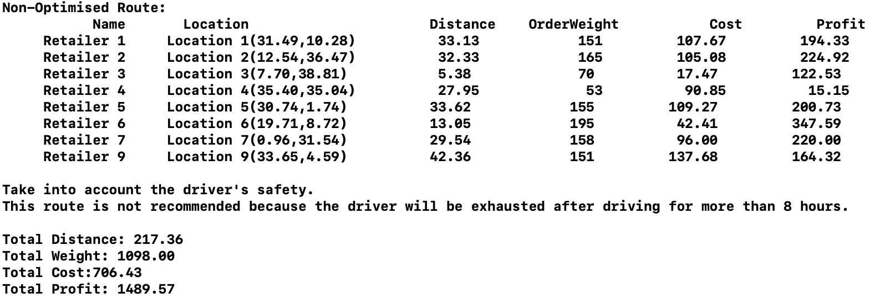

1. **CONTINUE AND QUITE**



1. **PRINT OUT IN FILE**

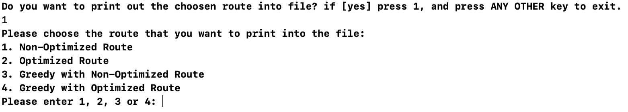

1. **CHOSEN ROUTE PRINT INTO FILE**

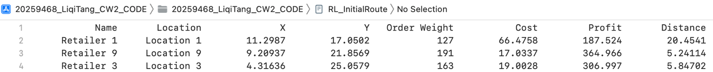

1. **FILE EXISTING CHECK AND INFORMATION WRITTEN CHECK**

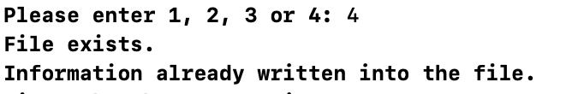

1. **EXECUTION TIME**

